

|  |
| --- |
| Bruce WenCMSC 118, Mid-term Report on Homelessness  Analyses on Data by HUD |
|  |

|  |  |
| --- | --- |
| 1  **A) Temporal Patterns in Number of Homeless People in Chicago and LA** | |
| Chicago (Fig. 1)~10% Decrease in Home- lessness from 2008 to 2018  * Large Decrease in Home-lessness from 2015 to 2018 * Chronically Homeless Indivi-duals remained largely the same from 2008-2018 * Sheltered total homeless rose to its highest in 2009, but decreased there-after to lowest level in 2018  Los Angeles (Fig. 2)Overall Homelessness decreased sharply from 2008-2009 but rose continuously to 50000, the highest, in 2017  * Sheltered total homeless remained largely similar from 2008-2018 despite rise in overall homeless | Fig. 2  Fig.1 Homelessness in ChicagoHomelessness in Los Angeles | |
| **Analysis**: Homelessness is a worrying problem in Los Angeles. Not only are there much higher homeless people in LA, the data suggests a rise in overall homeless even while the sheltered total homeless remains largely the same. In Chicago, while the trend suggests a lower overall homeless level in recent years, there is still concern over the decrease in sheltered total homeless. | | |

**B) Spatial Patterns in Homeless People in USA**

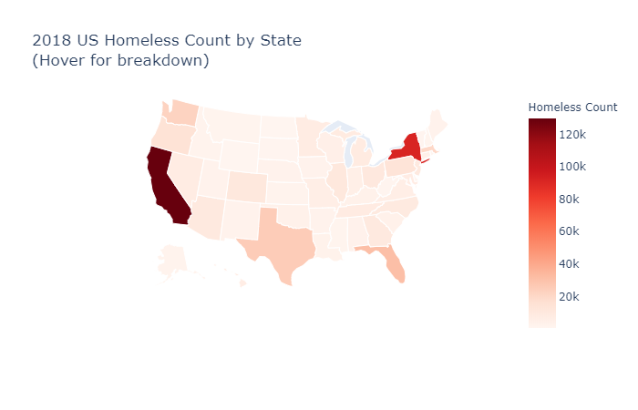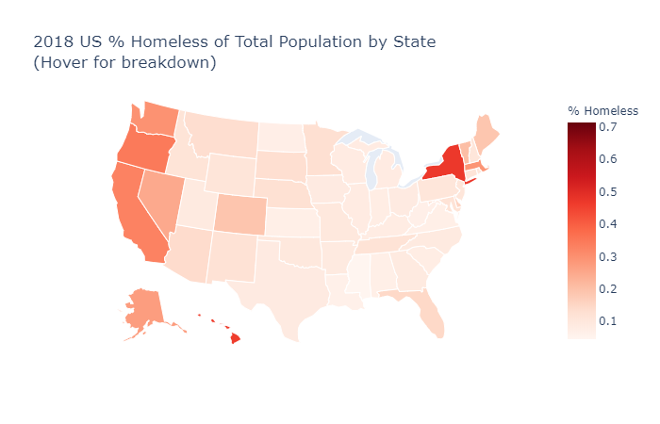

Washington

New York

California

Oregon

Washington

Oregon

New York

California

The most recent Homeless Count in 2018 is first analyzed. To determine spatial patterns, choropleths are plotted using *plot.ly* library in Fig. 3 & 4. Fig. 3 displays the absolute Homeless Count, while Fig. 4 accounts for relative population size, taking state population data from [*https://www.census.gov/data/datasets/time-series/demo/popest/2010s-state-total.html*](https://www.census.gov/data/datasets/time-series/demo/popest/2010s-state-total.html). The choropleths suggest **significant problems of homelessness in coastal states**, especially in California (130K homeless) & New York (0.47% homeless). Given the visual trends identified in the choropleths, further analysis is done by dividing the US map into regions and divisions, as in Fig. 5 and Fig. 6. Homelessness is **particularly a problem in the Northeast and West Regions**. Furthermore, the **Pacific and South Atlantic**

Fig. 3

Fig. 4

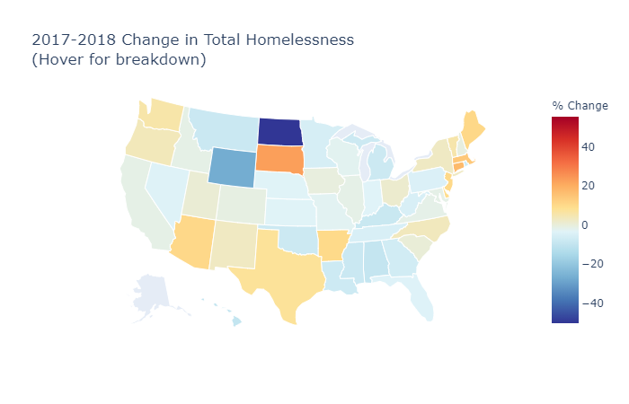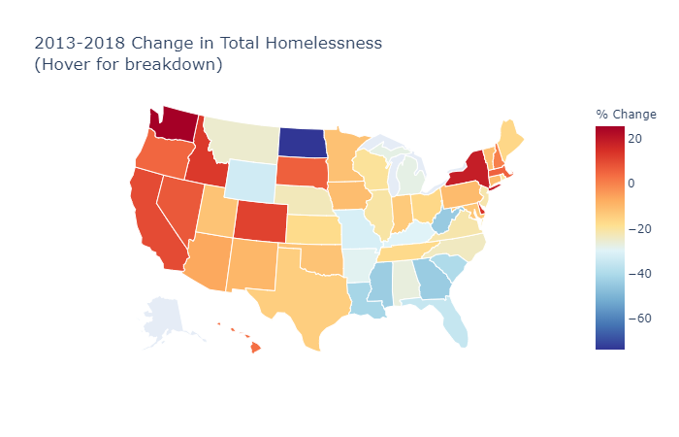

2

California

California

New York

New York

North Dakota

North Dakota

Fig. 9: Change in Beds across entire USA, 2013-2018

**C) Patterns in Bed Inventory Data**

Fig. 9 graphs the number of Emergency Shelter beds, Safe Haven Beds, Transitional Housing Beds and their totals from 2013 to 2018. Notably, **year-round safe haven beds** are a **small proportion** of total beds, and the decrease in transitional housing beds exceed the increase in emergency shelter beds, leading to a **decrease in total beds** (2013-2018).

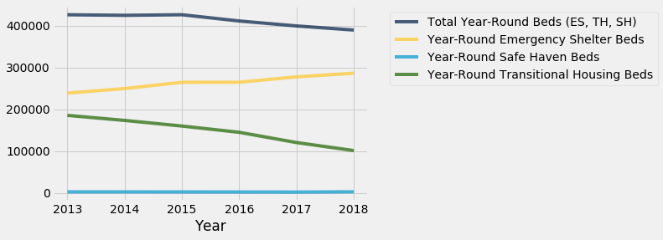

Further research is conducted on **temporal patterns** in homelessness across USA. Use of the *plot.ly library* choropleths in Fig. 7 and 8 above allows us to **view both the temporal and spatial patterns** of % change in homelessness in the same 2D space, while the RGB spectrum scale clearly contrasts the % change between the states. Analyzing the temporal patterns provides insights on the states that have especially worrying increase in homelessness lately, while also highlighting exemplary states with large decreases in homelessness that we could analyze further to investigate how the improvement was achieved. Comparison of Fig. 8 with Fig. 4 then allows us to focus on which states in particular require intervention efforts urgently.

Again, the **Western coastal and Northeastern states** present the most worrisome trends. However, the **Southeast states** and **Northern states** show general downward trends in homelessness.

**North Dakota** is especially insightful as it showed the ***largest decrease*** in homelessness in both 2017-2018 and 2013-2018, resulting in one of the lowest homelessness percentages in 2018, at 0.07%. Recognizing this, analysis into North Dakota’s recent homelessness policies was conducted. A “Housing the Homeless” report, published in 2018 by the North Dakota Interagency Council on Homelessness ([*https://www.ndhfa.org/Publications/Reports/Partner%20Publications/HomelessPlan2018.pdf*](https://www.ndhfa.org/Publications/Reports/Partner%20Publications/HomelessPlan2018.pdf)), explicitly states 3 strategies that have been implemented: ***1) Develop permanent supportive housing****,* ***2) Improve the ability to pay rent****, and* ***3) Expand supportive services to wrap around housing***. Given the strong evidence of decrease in homelessness, these strategies have high chance of working, and hence the validity of these measures should further be investigated in other states.

Notably, even though **California** has the highest homeless population in the United States, and it experienced a 9.6% increase in total homelessness from 2013-2018, there is a -1.2% decrease from 2017-2018. In contrast, despite **New York** having the highest percentage of homelessness at 0.47%, it continues to suffer from a 18.7% increase in homelessness (2013-2018) and 2.7% increase (2017-2018). The data evidently suggests that on a national level, attention needs to be focused on **NY** to mitigate homelessness.

Fig. 8

Fig. 7

**divisions, which contain the coastal states**, **make up more than 50%** of the total homeless in USA. Geographically speaking, the majority of efforts to tackle homelessness should hence be targeted towards the coastal states, in particular California, Oregon, Washington and New York, which demonstrate high homeless % and absolute count of homelessness.

Fig. 5: 2018 Home-less sum by Region

Fig. 6: 2018 % of Homeless in Divisions of United States

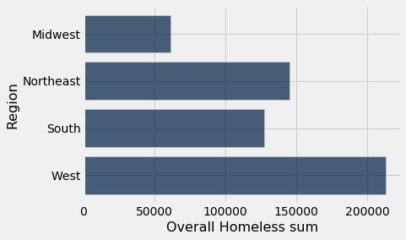

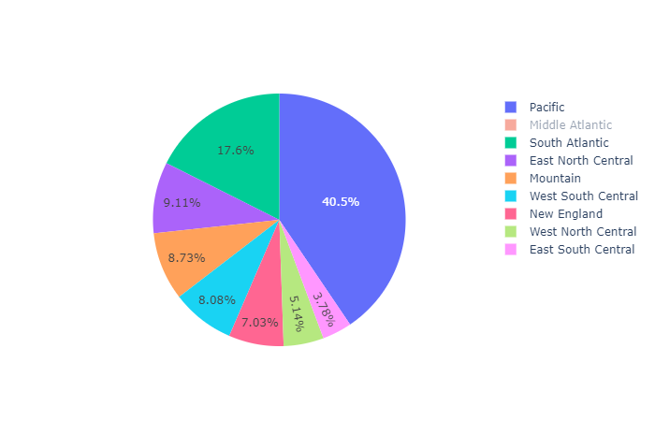

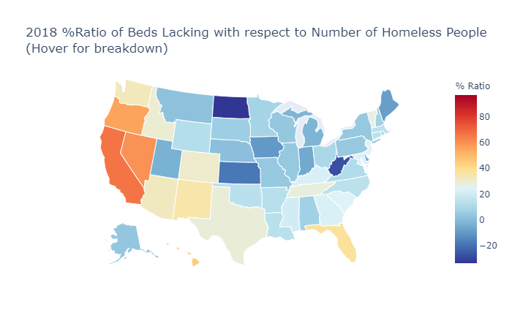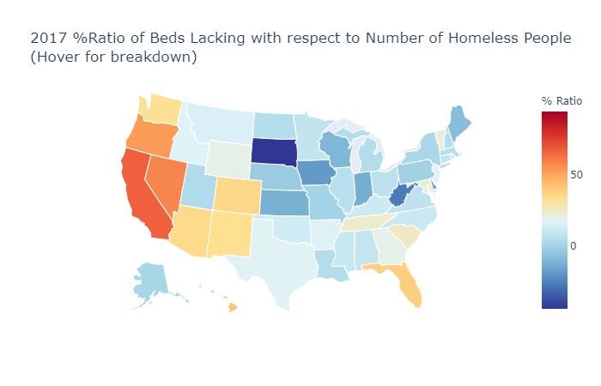

Florida

Florida

3

To investigate the correlation between the number of beds and the number of homeless people, further analysis is conducted as in Fig. 10, 11, & 12. Each state’s lack of beds is calculated by computing the difference between the total homeless population and the total available beds. The resultant value divided by the total homeless population, calculated for each respective state, is shown on choropleths using the *plot.ly* library. The respective choropleths for 2013, 2017 and 2018 are then plotted to show temporal patterns. Some states show large change, which are further analyzed:

1) In **North Dakota**, the decrease in ratio from *0.65* (2013) to *-0.33* (2018) (*negative* ratio indicates more beds than homeless) correspond to *-73.8% change* in homelessness (Fig. 8). This further substantiates

North Dakota

North Dakota

Fig. 10

Fig. 11

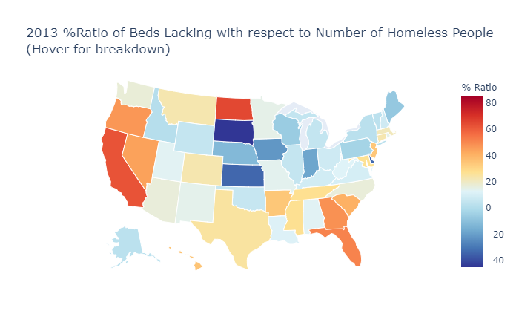

the report by North Dakota Interagency Council on Homelessness (pg. 2) and its strategy to **develop permanent supportive housing**.

2) In **Florida**, the decrease in ratio from *51%* (2013) to *37%* (2018) correspond to *-35.2%* change in homelessness (Fig. 8).

The above examples suggest an **association between decrease in beds lacking and decrease in homelessness**. This is further investigated by plotting a scatter graph (Fig. 13), using *numpy polyfit* module to plot the regression line and calculating the Pearson correlation coefficient through *scipy stats* module. A PPMCC value of **0.843** is obtained, indicating substantial correlation.

**Further Discussion**: There is strong evidence to suggest that there is an association. But it is difficult to say beyond reasonable doubt that a decrease in number of beds lacking ***causes*** decrease in homelessness. Further study is

Florida

Fig. 12

North Dakota

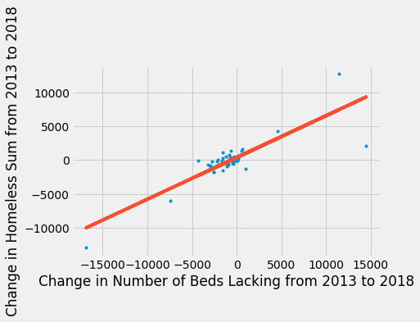

required to explore the reasoning behind the association and to determine if it is indeed a causation relationship.

Y = 0.6175251272106619x + 405.25711

Pearson correlation coefficient = 0.843

Fig. 13: Scatter Plot and Regression Line of Change in Homeless against Beds Lacking (2013-2018)

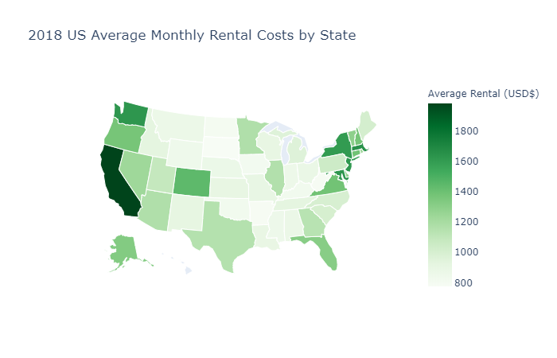 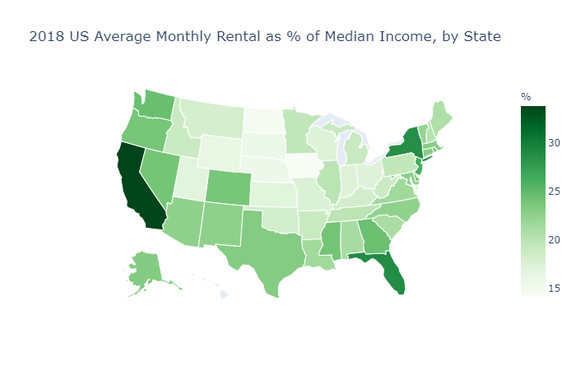

Nevada

Washington

Washington

Oregon

Oregon

Colorado

Colorado

New York

New York

Florida

Florida

California

California

Fig. 14

Various reports have linked rental costs with homelessness. This is intuitive, considering that it is the rent or property price that inhibits an individual from having a home. It is therefore imperative to explore this relationship. Data on average monthly rental costs by state is obtained from [*https://www.apartmentlist.com/rentonomics/rental-price-data/*](https://www.apartmentlist.com/rentonomics/rental-price-data/) and plotted as a choropleth map in Fig. 14. Median income data is processed from[*https://fred.stlouisfed.org/release/tables?rid=249&eid=259515#snid=259516*](https://fred.stlouisfed.org/release/tables?rid=249&eid=259515#snid=259516) and taken as the denominator of the ratio with rental cost, plotted as a choropleth in Fig. 15.

Fig. 15

**D) Relationship Between Rental Costs and Homelessness**

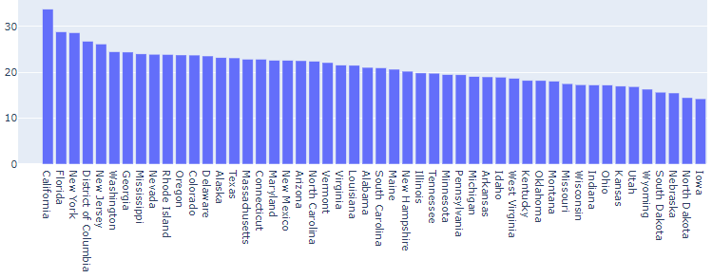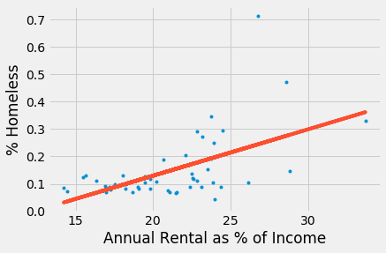

4

The 6 states described above have among the highest homeless % (Fig. 4), and also the highest average monthly rentals as % of median incomes (Fig. 15). To test the correlation considering the entire population of states in USA, Fig. 17 is a scatter plot and regression line of the comparison, via the same methodology described for Fig. 13. A relatively low Pearson correlation coefficient of **0.556** is obtained, which questions the notion of the correlation. We note that the data nevertheless show **strong correlation** between the two factors for the states with **high homelessness/high rental** **as % of median income**; the poor correlation statistic could be due to the mix of the other states with lower values of above. This is perhaps sensible, because when the annual rental is below a certain % of income, the individual may be able to afford housing regardless of small changes in prices.

Assuming that the states with highest rental costs face the most

significant homeless problem, it is then important to identify the **top few states** with highest rental as % of median income, which is shown in Fig. 16. Reducing the rental costs in these states (CA, FL, NY, DC, etc.) will likely lead to lower homelessness rates.

Fig. 17: Scatter Plot and Regression Line of 2018 % Homeless against Annual Rental as % of Median Income (all States are data points)

* CA: 33.7%, 0.33%
* OR: 23.8%, 0.35%
* WA: 24.5%, 0.30%
* CO: 23.7%, 0.19%
* NY: 28.6%, 0.47%
* FL: 28.8%, 0.15%

Of interest from Fig. 14 and 15 are those states with high average monthly rental as % of median income: these states have high % homeless as well (compare to Fig. 4). In particular, the following states [*State: Rental as % of median income, % Homeless*]:

Y = 0.0169x + -0.208

Pearson correlation coefficient = 0.556

Fig. 16: 2018 Annual Rental Costs as % of Annual Median Income, sorted in decreasing order by state

Through careful analysis and comparison of data, 5 key findings are proposed. *First*, comparing the city of Chicago and Los Angeles, there is a clear discrepancy in the severity of problem between the 2 cities; LA’s homelessness is rising while Chicago’s is decreasing. *Second*, regional trends in homelessness have been identified; in particular, it has been shown that homelessness is particularly a problem in the **Northeast and West** regions, and **Pacific and South Atlantic** divisions. Third, through analysis of spatial and temporal trends together on the choropleth maps, it has been shown that **Western coastal** and **Northeastern states** present the most worrisome homelessness trends in the past 5 years. Interestingly, the example of North Dakota presents an enlightening example on fighting homelessness. Fourth, it has been demonstrated that there is a **strong correlation** between **decrease in beds lacking and decrease in homelessness** (PPMCC=0.843). Fifth, **rental costs as proportion of median income** has been shown to be **associated with homelessness, especially** for the states with the **highest rental costs**.

*Based on the above conclusions, the following recommendations are suggested*:

**1)** **Focus National Efforts** on resolving homelessness on the **Northeast & West regions, Pacific & South Atlantic divisions**. The states New York, California, Washington and Oregon are especially in need of intervention and focus of government efforts to resolve homelessness. This could be in the form of directing specific area-oriented policy efforts or additional funds towards these areas.

**2)** Adopt the successful policies of North Dakota in combating homelessness in other states across America. North Dakota experienced a *-73.8% change* in homelessness from 2013-2018, and its 3 key policies of **a*) Develop permanent supportive housing****,* ***b) Improve the ability to pay rent****, and* ***c) Expand supportive services to wrap around housing*** are worth studying in their applications to other states battling homelessness.

**3)** Further investigate the causation effect of **change in ratio of beds lacking to change in homelessness**, while continuing to **provide for more beds to reduce and mitigate homelessness**. A strong association has been demonstrated between homelessness and the lack of provided shelter beds, and further study into this could prove insightful.

**4)** For states with particularly high rental cost, focus efforts on **reducing rental fees in relation to median income**. This could perhaps be in the form of directing government funds to subsidize the construction of more housing.

**Conclusion and Discussion on Resolving Homelessness**